

**Troy Elementary School**

**Second Grade Supply List**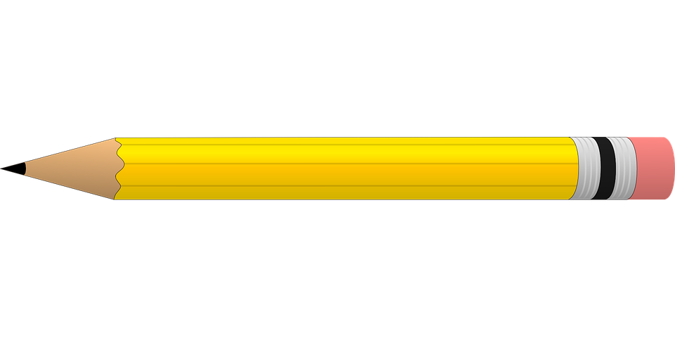

**2025-2026**

| **Required items:**   * 4- packs of 12 (#2) pencils * 2- packs of wide ruled notebook paper * 2- 2 pocket folders with 3 holes: 1 green, 1 blue   (please do not label)   * 1 pair of scissors * 2- wide ruled notebooks (with 70 pages) * 2- boxes of 24 count crayons * 1- package of colored pencils * 1- small school supply pouch * 2- jumbo glue sticks * 2 large pink erasers | **Optional items (Greatly Appreciated):**   * 2- rolls of paper towel * GIRLS- 1 box of Ziploc bags-gallon size * BOYS-1 box of Ziploc bags- quart size * Disinfecting wipes * Lysol spray * Kleenex * Hand soap * Hand sanitizer |
| --- | --- |