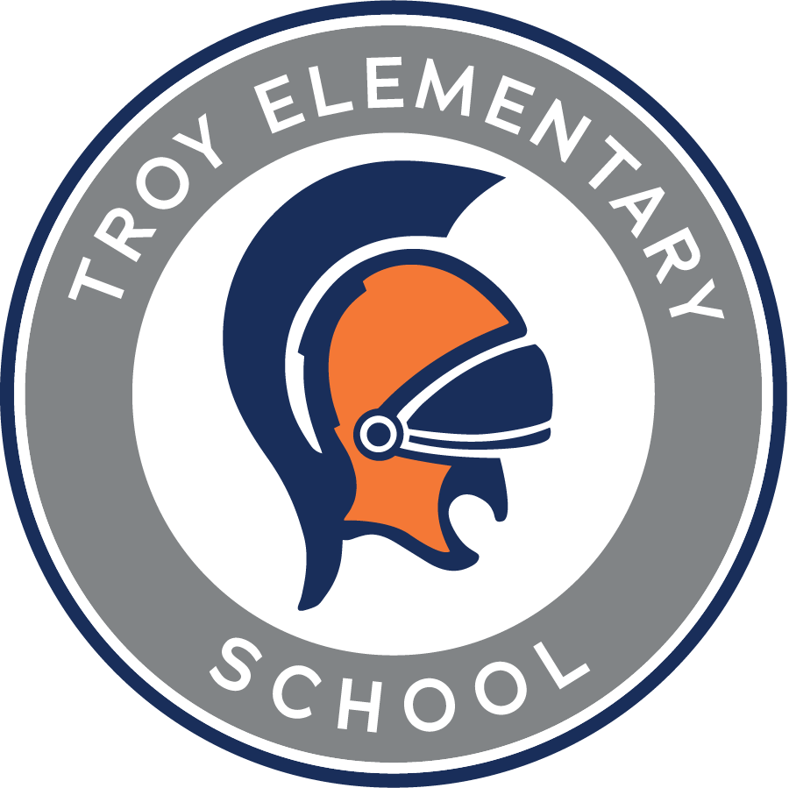

**Troy Elementary School**

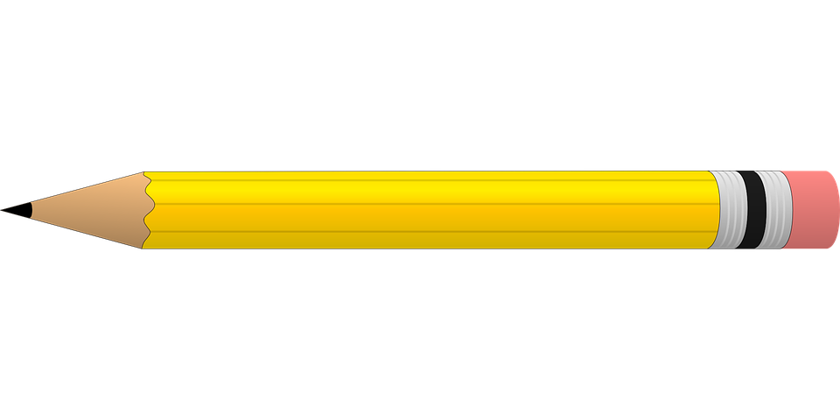**Kindergarten Supply List**

**2025 - 2026**

| **Required items:**   * Ziploc bag with complete change of clothes with label from teacher * 4 packs - 24 count Crayola crayons   **NO LARGE OR THICK**   * 6 Elmer’s glue sticks (small)   **NO SCENTED**   * 1 pack - 10 count classic Crayola washable markers * 1 pair of blunt tip Fiskars scissors * 1 wide ruled composition notebook   **NO CHARACTERS**   * 1 refillable water bottle with lid and name label | **Greatly Appreciated, but Optional:**   * **GIRLS** - 3 rolls of paper towels * **BOYS** - 3 boxes of Kleenex * Disinfecting wipes * **GIRLS** - 1 box of gallon size Ziploc bags * **BOYS** - 1 box of quart size Ziploc bags * Band-Aids * Lysol spray * White cardstock (8 ½” by 11”) |
| --- | --- |