

**Troy Elementary School**

**Third Grade Supply List**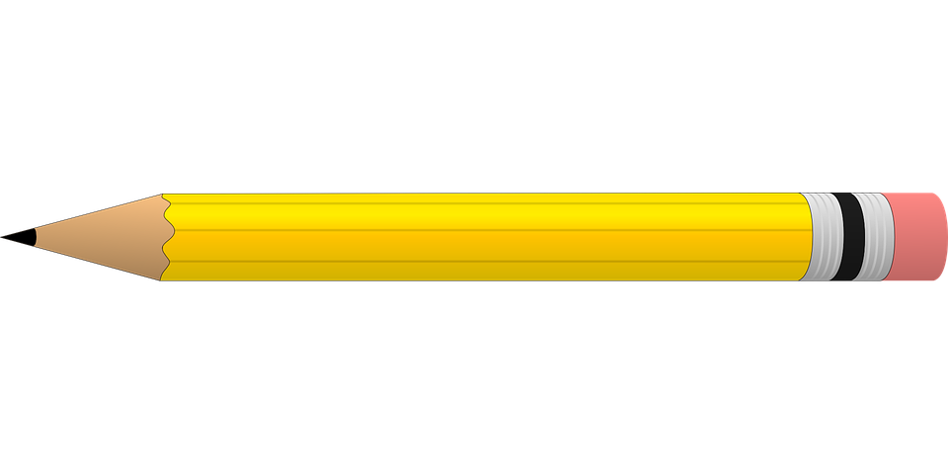

**2025-2026**

| **Required items:**   * 2 packs of 12 pre-sharpened #2 pencils **(Please NO mechanical pencils)** * 1 pair of scissors * 4 glue sticks * 1 box of 24-count crayons * 1 pack of 12 colored pencils * 4 WIDE ruled composition notebooks **( NOT spiral)** * 4-count pack of black expo markers * 2 zipper pouches (one for supplies, one for binder; no boxes) * 1 package of HEAVY DUTY sheet protectors * 1 plastic folder with pockets (any color) | **Optional items (Greatly Appreciated):**   * Hand sanitzer * Paper towels (2) * **GIRLS**- 1 box of gallon size Ziploc bags * **BOYS**-1 box of quart size Ziploc bags * Clorox wipes (3) * Lysol spray * Kleenex (3) * Hand soap * Baby Wipes (2) * Colored copy paper(Astrobright) |
| --- | --- |