

**Troy Elementary School**

**First Grade Supply List**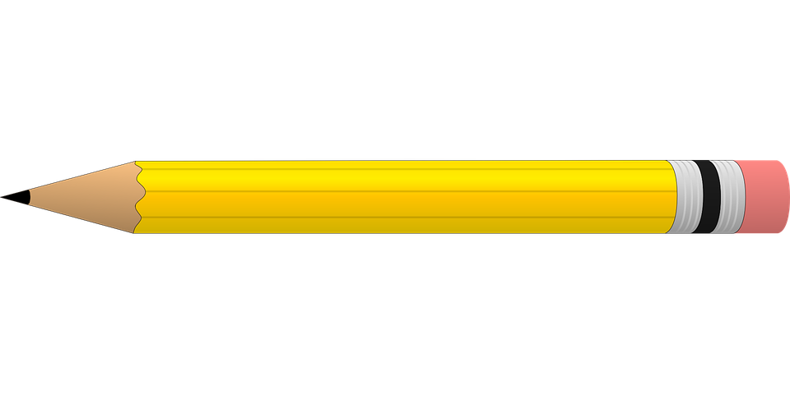

**2024-2025**

| Required items:   * Fiskars Scissors * 2 packs of yellow #2 pencils (NO mechanical or decorative) * 10 glue sticks * 3 individual boxes of 24-count crayons * 1 regular plastic supply box (NO fluffy or zipper options) * 2 large pink erasers * 1 WHITE one inch hard side binder with inside pockets * 10 black dry erase markers | Optional items (Greatly Needed):   * Germ-X * 2- rolls of paper towel * GIRLS- 1 box of gallon size Ziploc bags * BOYS-1 box of quart size Ziploc bags * Disinfecting wipes * Lysol spray * Kleenex * Hand soap * Band-Aids * Copy paper |
| --- | --- |