

**Troy Elementary School**

**Fifth Grade Supply List**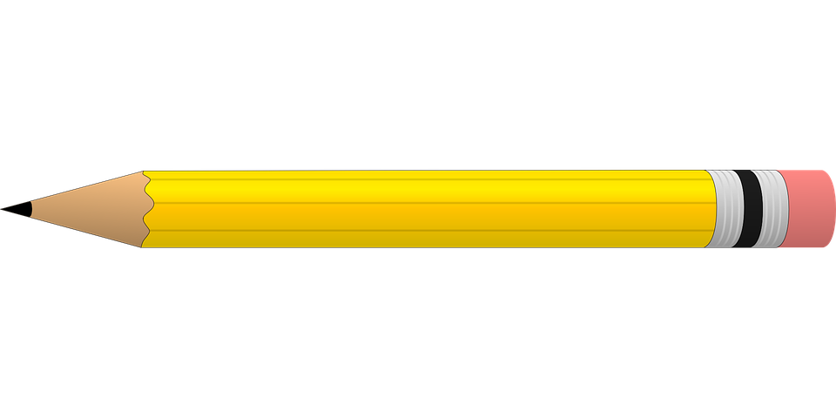

**2024-2025**

| Required needs:   * 2 packages of #2 pencils * Pack of highlighters * Dry erase markers * Handheld pencil sharpener with a lid * 1- box of crayons * 1 pack of colored pencils * 1 pack of washable markers * 2 packages of wide ruled notebook paper * 2 wide ruled composition notebooks * Zipper close pencil pouch for binder * 2 packs of Notecards or Index Cards * 1- pack of copy paper   **\*\*\*1- two inch binder & 1- 5 pack of pocket dividers will be provided to every student\*\*\*** | Optional items (Greatly Needed):   * Germ-X * 2- rolls of paper towel * Disinfecting wipes * Clorox Wipes * Kleenex * Hand soap * Band-Aids * 1- 2 inch Binder * 1- 5 pack **Pocket** dividers * **Mouse**(wireless or plug in) they will be used DAILY in class |
| --- | --- |