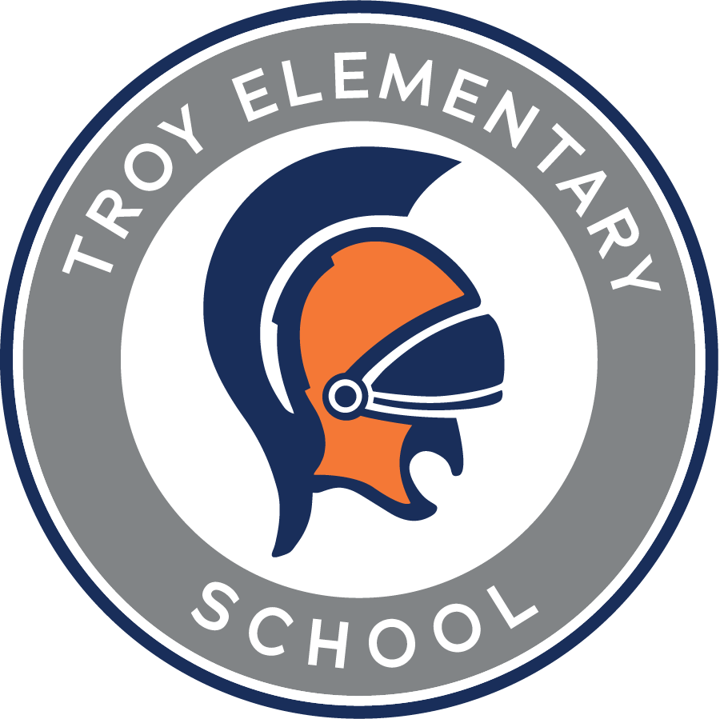

**Troy Elementary School**

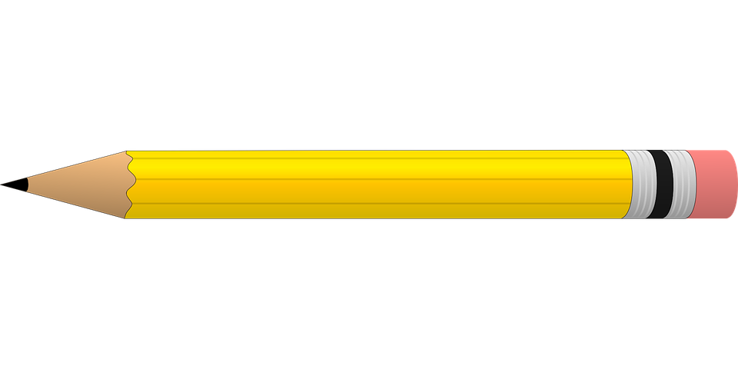**Kindergarten Supply List**

**2024 - 2025**

| Required Items:   * Ziploc bag with change of clothes with label from teacher * 4 packs - 24 count Crayola crayons   + **NO LARGE OR THICK** * 10 Elmer’s glue sticks   + **NO SCENTED** * 2 packs - 10 count classic Crayola washable markers * 1 pair of blunt tip Fiskars scissors * 1 plastic supply box * 2 packs - #2 sharpened pencils   + **NO THICK** * 2 plastic folders with prongs and pockets   + **ORANGE AND BLUE** * 1 refillable water bottle with lid and name label * 4 thin black dry erase markers | Optional items (Greatly Needed):   * 3 rolls of paper towel * 3 boxes of Kleenex * Disinfecting wipes * White copy paper * **GIRLS** - 1 box of gallon size Ziploc bags * **BOYS** - 1 box of quart size Ziploc bags * Band-Aids * Lysol spray * Germ-X * Hand soap * White cardstock * Colored copy paper * 1 wide ruled composition notebook (No Characters) * 1 wide ruled spiral notebook (No Characters) * 2 primary writing tablets * 1 can of Play-doh |
| --- | --- |

Supplies may need to be replenished throughout the school year. Your teacher will notify you if a need arises.