2nd Grade Monthly News! November 2018
Monday | Tuesday | Wednesday | Thursday | Friday | WEEKLY FOCUS!
 |  |  | 1 | 2  Lisenby T-Shirt Day | Story: One Good Turn  Phonics: Long a: a, ai, ay  Grammar: Possessive Nouns  Math: EngageNy-Module 3 Lessons 9-11 |   Congratulations to our October bucket filler,  Madelyn Reznikov  Way to go!!!!   Daylight Savings Time Ends November 4th. Don’t forget to Fall back 1 hour! 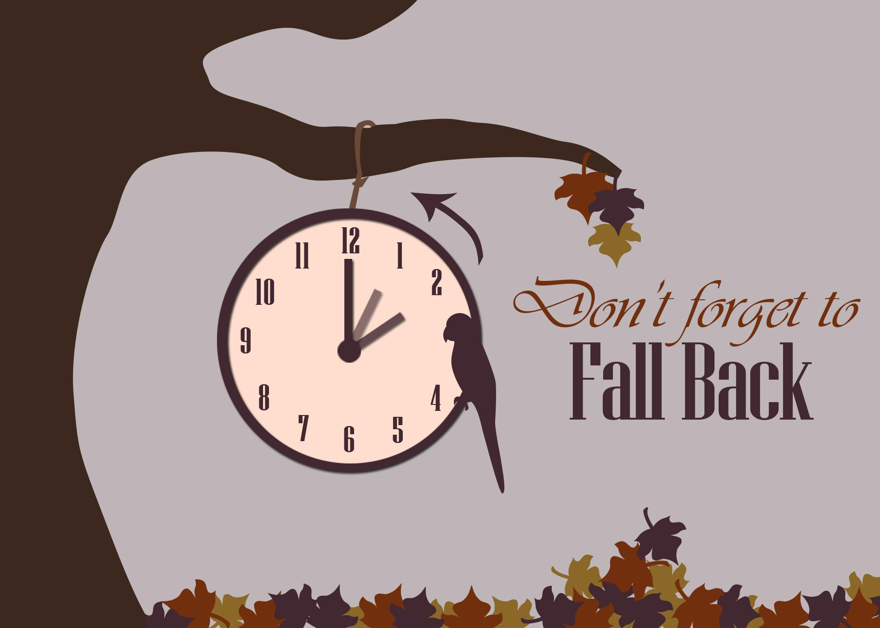  Thanksgiving Break is the week of November 19-23!  I hope you all have a Happy Thanksgiving!
5  Review and take benchmark  test | 6  Review and take benchmark test | 7  Start new story and skills | 8 | 9  Teacher Work Day! | Story: Pearl and Wagner Phonics: Vowel patterns e, ee, ea, y Grammar: Verbs  Math: EngageNy-Module 3 Lesson 12-14
12  Veteran’s Day  No School | 13  continue new story and skills | 14 | 15 | 16  Alabama/  Auburn Day | Story: Pearl and Wagner Phonics: Vowel patterns e, ee, ea, y Grammar: Verbs  Math: EngageNy-Module 3 Lesson 15-17
19  Thanksgiving Holiday | 20  Thanksgiving Holiday | 21  Thanksgiving Holiday | 22  Thanksgiving Holiday   | 23  Thanksgiving Holiday | 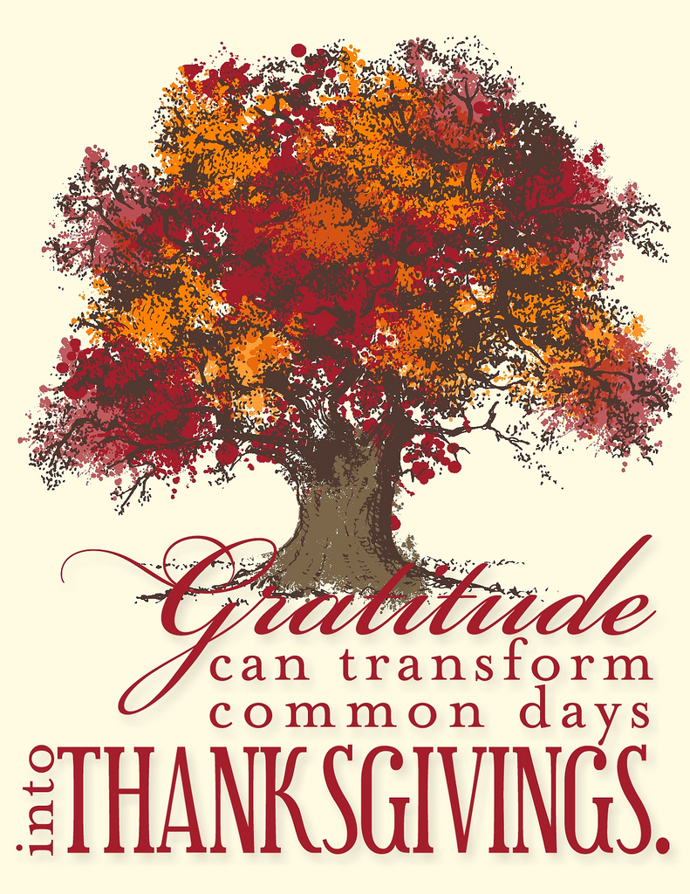
26 | 27 | 28 | 29 | 30 | Story: Dear Juno Phonics:long o (o, oa, ow) Grammar: verbs with singular & plural nouns  Math:EngageNy-Module 3 Lessons 18-21

