

**Troy Elementary School**

**Sixth Grade Supply List**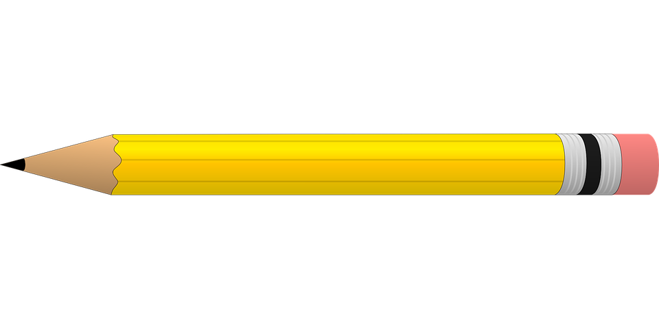

**2024-2025**

| Required needs:   * Wide-ruled notebook paper * Post-it notes * 4-Sewn composition notebooks (**NO Spirals)** * Pencils * Sheet protectors **(ELA)** * Expo Markers **(Math)** * Index cards **(Math)** * Crayons - 24 count **(NO Markers)** * Highlighters * Liquid glue * 3-ring Pencil pouch * Large or Extra Large book bag | Optional items (Greatly Needed):   * Germ-X * 2- rolls of paper towel * **GIRLS**- 1 box of gallon size Ziploc bags * **BOYS**-1 box of quart size Ziploc bags * Disinfecting wipes * Kleenex * Hand soap * Band-Aids |
| --- | --- |